

**Arizona Robotic Telescope Network (ARTN)**

**Technical Approach and Requirements**

Draft (rev. 2)

21 July 2017

|  |  |
| --- | --- |
| **Technical Point of Contact**  Dr. Eric C. Pearce  University of Arizona, Steward Observatory |  |

# Objective

The University of Arizona Steward Observatory operates or has interests in over 20 telescopes at six locations and on the main campus in Tucson, Arizona. One three of these sites (Mt. Lemmon, Mt. Bigelow, and Kitt Peak) the University has direct operational responsibility. Currently, these telescopes operate largely independently using a diverse mix of operating systems and control architectures. Most of our telescopes are currently classically scheduled and used to support the scientific research of the faculty, students, and collaborators of the University.

The Arizona Robotic Telescope Network (ARTN) is envisioned to consolidate the operations of many of these telescopes using a multi-layered approach, and incrementally improve the capabilities and sustainability of our telescope systems. The ARTN will enable the fully integrated telescopes to be operated remotely in queue mode, greatly improving our operational efficiency and enabling more flexible and agile telescope scheduling to support our diverse observing needs. Additional motivation for the ARTN are streamline operation and allow more effective use of the telescope resources and staff time to minimize instrument changes and increase the variety of observing capabilities that are available simultaneously.

Network operations will be consolidated into a single control facility, ARTN-Ops, where a single operator can monitor, control and intervene with individual telescopes as necessary. Individual telescopes will be able to be remotely operated from any location given adequate network bandwidth and security infrastructure is available. Defining functional requirements for ARTN-Ops is one of the significant tasks ahead of us towards implementation of the ARTN.

With respect to our educational mission, we also intend to retain the ability to classically schedule and operate telescopes, either remotely or from the mountaintop, to facilitate student “hands on” experience with astronomical systems, and to allow maximum flexibility to develop new observing techniques and programs. The queue observing and flexibility of ARTN will also enhance student observing programs, reducing weather risk to their observing programs which are typically only allocated a small number of nights.

The ARTN will support a wide range of observing for both astronomy and space situational awareness. Additionally, ARTN functional requirements are driven by our need to support student educational and public outreach programs, and to streamline our operations, maintenance, and sustainment of our diverse suite of telescope systems.

This document describes the overall system architecture and scientific goals of the ARTN. Section 2 describes the envisioned system level architecture and functionality of the ARTN.

Section 3 outlines the high level functional requirements of the ARTN and motivating research that drive these requirements. The intent of this section is to summarize the current and envisioned science programs that the ARTN will support, including traditional astronomy, space situational awareness (SSA), and education. This section will develop key performance parameters (KPPs) necessary to support that particular scientific or SSA endeavor. The specific list of KPPs will be detailed in that section. In general, they capture high level requirements in three specific areas: (a) sensor performance (resolution, limiting magnitude, band, etc), (b) response time, and (c) operational tempo.

Section 4 outlines the development plan and considerations going forward with the implementation of the ARTN.

# ARTN System Architecture

## System Architecture

The ARTN system architecture is a functional layered architecture, where each additional layer adds a level of sophistication. A summary view of this architecture is shown in Figure 1. The lowest layer of the control architecture, Telescope Control System (TCS), is responsible for the low level servo and mechanism control of telescope mount, dome, and auxiliary equipment. This level interacts directly with the telescope hardware and presents standard interfaces to the Observatory Control System (OCS) layer to provide basic functionally of the telescope system, such as slewing, tracking, opening and closing shutter doors, and similar functions.

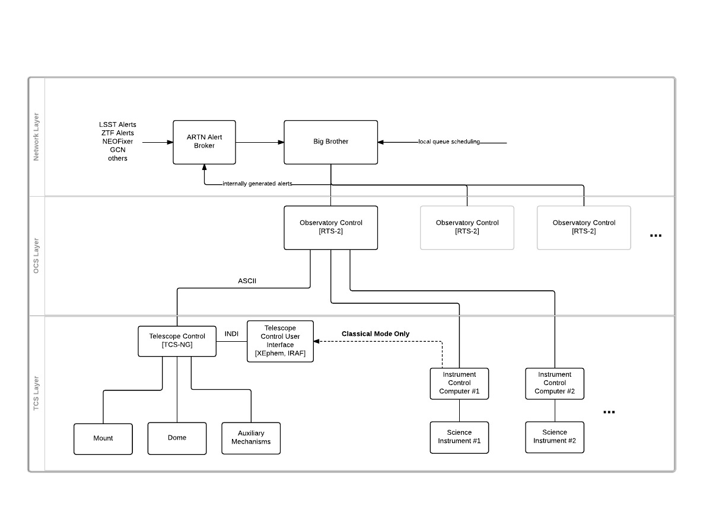

Figure . High Level Functional Block Diagram of the ARTN System.

At the next level, the Observatory Control System (OCS) integrates the operation of the telescope mount, dome, and instrument systems to implement specific astronomical measurements and calibrations. Additionally, the OCS provides the capability to script or automatically sequence the operation of a single telescope system to perform more complex observing programs.

The final layer of the control architecture is the Network Control System (NCS). This level allows centralized resource management and brokering of queued measurements and responses to internal or external alerts to be allocated to one or more telescopes in the ARTN. This layer also provides a graphical user interface to allow monitoring of the ARTN network status and the status of the telescope systems operating within the network.

### Telescope Control System (TCS)

The lowest level of telescope control is implemented by the Telescope Control System (TCS). The TCS is responsible for low level control of the telescope mount, dome, and auxiliary equipment such as the telescope focus mechanism, dome shutter and ventilation doors, and other support equipment. Currently, Steward Observatory is upgrading most of our telescopes to a system called New Generation TCS, or TCS-NG. TCS-NG provides a set of simple text commands to the OCS level to implement basic telescope operations. Currently six telescopes have been either upgraded to TCS-NG or are nearing completion and transition to TCS-NG.

Many Steward Observatory telescopes are running older outdated control systems. Several, including the SuperLOTIS, Bok 90”, and the MMT[1] are still running the Comsoft PC-TCS that was used prior to the development of TCS-NG. The two Spacewatch telescopes on Kitt Peak run a custom TCS which was developed by Spacewatch. The Schulman Telescope uses a low level control system developed by Las Cumbres Observatory. Finally, the Minnesota 60” telescope uses an archaic control system supported with FORTH software. The upgrade path for the legacy systems will be outlined in Section 4.

#### New Generation TCS (TCS-NG)

New Generation TCS (TCS-NG) is the newest in a line of telescope control systems used by Steward Observatory. TCS-NG’s was originally written in Z80 assembly language, then rewritten in C for the MSDOS platform, then ported into the VXWORKS real time unix environment. Most recently, it has been extensively updated to run under the QNX 6.5 real time operating system.

The TCS-NG software has three main parts: a servo loop (position), an astronomical engine, and a socket interface. The socket interface runs in a low priority non-real time thread. This interface is plain ASCII text and can very easily be controlled using command line tools in Linux. The astronomical engine runs on a timed interrupt and is as a real time thread. This engine is very complex and solves astronomical positions and corrections (precession, nutation, refraction, flexure, periodic error...) in real time. Recently it has been upgraded to also propagate satellite two-line element sets (TLEs) and asteroid element sets to allow tracking of non-sidereal objects. The servo algorithm controls the pointing and tracking of the telescope. TCS-NG can either run using its own servo loop control, or communicate directly to a servo control via Ethercat.

Configuration of TCS-NG is accomplished through the ASCII text interface using configuration files on the host computer. Each line of the configuration file has a keyword/value pair.

TCS-NG runs on PC104 hardware. We have been slowly improving the portability and hardware independence of the TCS-NG code base so that we can be extremely flexible in future iterations. In the future we hope to modularize OS dependencies so that we can port to other operating systems.

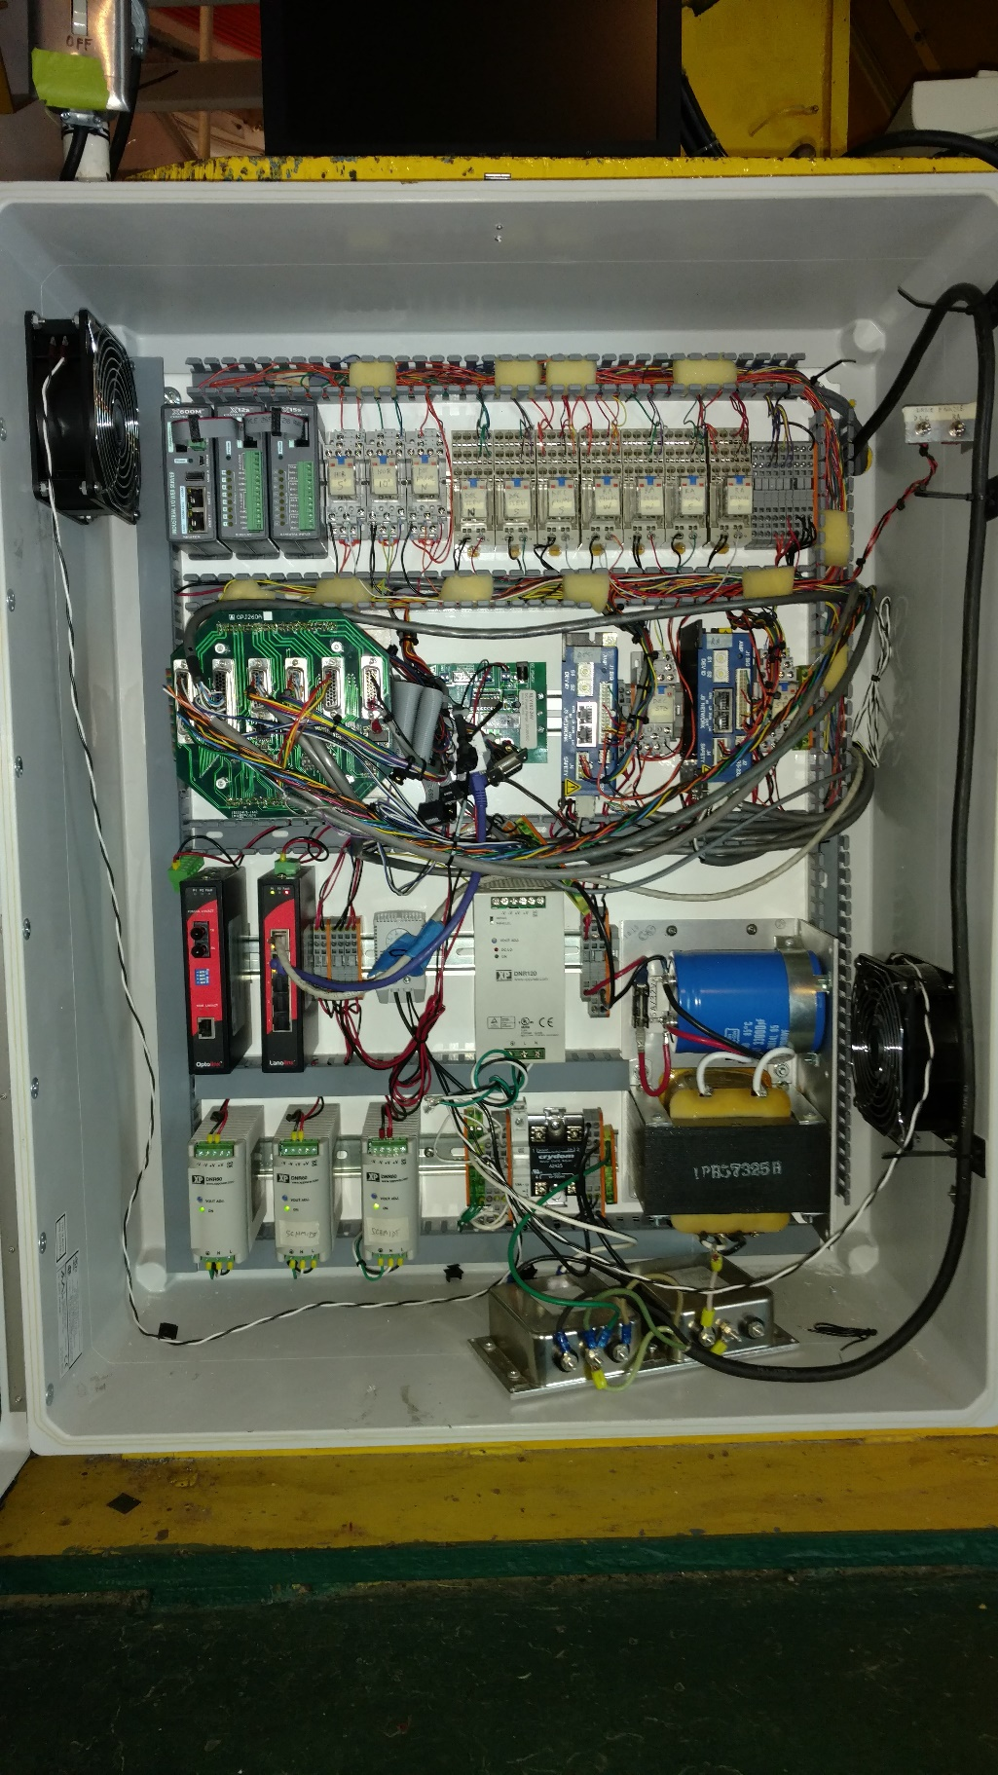

Figure . The NG-TCS Control Hardware on the Kuiper 61" Telescope (June 2017).

#### Legacy TCS

New Generation TCS has incrementally replaced an older systems called Comsoft PC-TCS on Steward Observatory telescopes—often called “Legacy TCS” at Steward Observatory. Legacy TCS was originally developed 1990'sand sold commercially by Comsoft Inc. Its developer, Dave Harvey, worked at Steward Observatory.  Legacy TCS runs on standard PC hardware running the DOS operating system DOS and uses ISA cards and some proprietary hardware.  Separate versions of Legacy TCS were used for stepper and DC servo drive mounts.  Many of the Steward Observatory telescopes used custom builds of Legacy TCS because it was not configurable enough to handle all of our needs. Legacy TCS had a graphical user interface integrated into the system and used a serial interface for remote operation.

As of June 2017, Legacy TCS is still in use on two Steward Observatory telescopes., the Bok 90" and the SuperLOTIS.

#### COTS Control Systems

One of the advantages of our collection of astronomical telescope systems is the diversity of our systems. Each has its own story and developmental legacy. While the effort to deploy TCS-NG and RTS-2 to as many Steward Observatory telescopes as possible will increase commonality and our ability to maintain and operate our systems effectively, its penetration will never be 100%. The proliferation of commercial off-the-shelf (COTS) hardware and software and shared open source software is likely to be a component of any future network of telescopes at Steward Observatory.

As a consequence of these factors, ARTN must be able to support COTS and other open source control systems at both the TCS and the OCS level. We anticipate that the use of ASCOM as an interface into various elements of the TCS control layer will be an unavoidable reality. Similarly, the widespread use of ACP[2] at the OCS layer will be necessary to accommodate as well.

#### Instrument Control and Interface

The instrument control and interface to the OCS layer of the architecture is a significant challenge in the implementation of ARTN. Often PI instruments are developed independently and have their own instrument control and data acquisition system, and the associated interfaces to the instrument itself, its supporting infrastructure, and the OCS. Many Steward instruments already have a robust, and semi-standardized system called AzCam, developed by the UA Image Technology Laboratory. This includes Mont4K CCD camera on the Kuiper Telescope and the 90Prime CCD camera on the Bok 2.3 m Telescope. The AzCam system will be discussed in greater detail below.

Other instrument control systems and commercial astronomical cameras use commercially developed software. For example, the Andor F9000 camera on the Pomenis Astrograph is controlled by MaxIM DL, and its focuser is controlled by FocusMax, both of which provide an ASCOM compliant interface to the OCS layer of the Pomenis control system, ACP. The Chimera High Speed Photometer uses Princeton Instruments LightField for camera control, and an interface to the OCS layer has not yet been developed for this instrument.

##### AzCam Data Acquisition System

### Observatory Control System (RTS-2)

Steward Observatory has selected Remote Telescope System Version 2 (RTS-2) for the standard solution for telescope control at the OCS level. RTS-2 is an integrated open source software package that runs under the Linux operating system and provides integrated control of the telescope, dome, and instruments. RTS-2 can operate a telescope system totally autonomously, coordinating telescope pointing, image acquisition, and scheduling. RTS-2 also integrates dome operation, and weather sensors for telescope safety and has some support the satellite tracking to support SSA.

RTS-2 is currently in developmental deployment on the White 21” and the Kuiper 61” Telescopes.

### Network Control System (Big Brother)

The Network Control System (NCS), currently named “Big Brother”, controls the entire network and serves as the central hub for brokering locally generated cued tasks, receiving and brokering external alerts, and provides an operator interface into ARTN to monitor and intervene in operations as needed. The functional requirements the NCS flow up from the KPPs developed by the science requirements, but also must consider the architectural and operational goals of the ARTN.

For example, consider the current handling of GRB alerts, which are received and handled locally by SuperLOTIS. To first order, this satisfies the originally intended science requirement. However, it does not allow for the ARTN network to address these requirements, perhaps by allocating a different available telescope if SuperLOTIS in not currently available.

Planning and requirements definition for NCS layer of ARTN has not been started.

## Existing Steward Systems with ARTN-Like Features

It is important to note that some of our telescope systems already have features that are relevant to the ARTN goals and have served as pathfinders and prototypes for our efforts. Several of the telescope systems have completed the NG-TCS upgrade, and have some level of automation or remote operation already implemented, usually with a custom or commercial implementation of the OCS control level. Most of our telescopes still require on-site personnel for telescope, dome, and instrumentation start. A summary of these capabilities (June 2017) is provided in Table 1. A brief description of the current capabilities of some of these systems is described in the subsequent sections.

Table . Summary of Control and Remote Operations Features of Current Telescopes.



### Vatican Advanced Technology Telescope (VATT)

[text from Gabor re current VATT system, science and ongoing program requirements and expectations]

### Kuiper 61” Telescope

[incomplete] The Kuiper Telescope has already been upgraded with the New Generation TCS (TCS-NG). Dome opening and closing requires manual operation and sequencing of wind screen and dome doors from the observing level. AzCam provides instrument operation and control, interfaced to a developmental RTS-2 via two custom RTS-2 drivers to the NG-TCS and AzCam.

### Schulman Telescope

The Schulman 0.8m Telescope is used primarily for astrophotography and public outreach. In addition to on-site public programs, the telescope is also used remotely in real time as well as through scheduled observations. Recent modifications to the script/scheduling engine ACP now enable satellite astrometric observations for UA SSA. The telescope uses the LCOGT TCS. LCOGT presents an ASCOM compliant interface to ACP and allows commercially available software such as ACP to control the telescope and all other ancillary observatory equipment.

### Pomenis Astrograph

The 180 mm Pomenis Astrograph is part of the Steward Observatory system development to support SSA with synoptic survey of geosynchronous and other deep space satellites to a limiting magnitude of approximately 16 *mv*. The low level control system of Pomenis is provided completely by commercial software with Software Bisque TheSkyX Professional (mount)[3], MaxIM DL (camera and filter wheel) and FocusMax (focuser) providing the control at the TCS layer. DC-3 Dreams ACP Expert 8.1 provides scripting and observatory control, implementing the OCS layer.

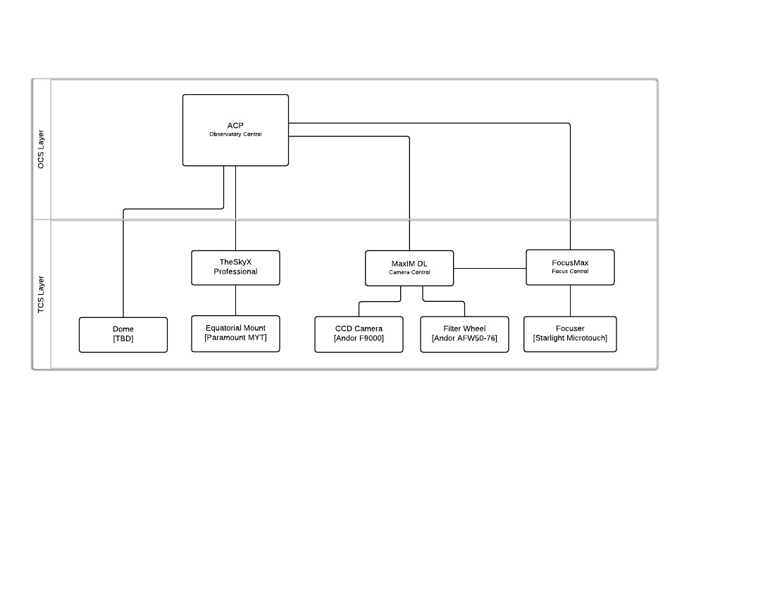

Figure . Functional Block Diagram of the Pomenis Astrograph Control System.

### SuperLOTIS

Originally developed for the optical detection and measurement of optical counterparts to GRB. The SuperLOTIS has the native capability to respond to external alerts from the Gamma-Ray Burst Coordinate Network (GCN) and has its own queue schedule capability for supernovae measurements. The SuperLOTIS still runs with Legacy TCS as its low level control system.

### Catalina Sky Survey (CSS)

[Input from E. Christensen, how CSS sees themselves fitting into ARTN or operating independently from ARTN, especially in terms of current CSS OCS level control, NEOFixer, and ARTN’s RTS-2 and NCS level control]

## Requirements Analysis and Flow

The requirements analysis and flow down for the ARTN is by necessity non-traditional. Significant development has already been completed the incremental upgrades replacing legacy TCS with NG-TCS and with preliminary work on the OCS level with RTS-2 to NG-TCS interface and driver development. This has been guided by a pragmatic bottom-up developmental strategy to makes the lower level control systems reliable and support automated and remote operation. Simultaneously, the science programs that have utilized Steward Observatory telescopes have been guided by the current capabilities and operability of those systems. In some cases, upgrades to instruments and control systems have been made to expand the science that we can accomplish with those systems.

As we look to the future of automated astronomy, and the inevitable impact of the large survey systems such as LSST and Kepler enabling and revitalizing the need for responsive smaller telescope, we have a unique opportunity with ARTN. Within this document, we fuse the architectural and operational considerations to our science and observational requirements. On the one hand, we have the current common-sense architecture that we are already committed to and our need to streamline operations and increase flexibility. On the science side, we have a need to continue to support our current science programs, enable expansion of those programs by leveraging greater integration of network wide queue scheduling and automation, enable responsive measurements to support transient astronomy and periodic measurements to support long-term surveys.

In terms of science requirements, we will use the current Steward Observatory research to set a baseline for the observational requirements that ARTN must support. This will identify and prioritize needed automation of instrumentation and specific observational protocols. It will also quantify performance requirements such as instruments, sensitivities, field-of-view, tracking requirements, observational tempo and frequency. This will be captured as key performance parameters (KPPs) for each science program, and consolidated to ensure that the implementation plan and technical capabilities of ARTN address these requirements, and enable the future research that we envision.

# ARTN System Level Requirements

## Time Domain Astronomical Community Considerations

Currently some UA telescopes are responding to alerts from the time domain astronomical community. Our handling of these alerts is typically at the single telescope level and is no case is the alert processing centrally filtered or brokered. The best example of this Super-LOTIS system at Kitt Peak, currently operated by the Steward Observatory. The Super-LOTIS is 0.6 m fully robotic system originally designed to detect prompt optical emission from GRBs. The Super-LOTIS responds to alerts from the Gamma-ray burst Coordination Network (GCN) within seconds. [Perez-Ramirez et. al. 2004]

### External Network Alerts

The implementation of queue observing on larger SO telescopes enables response to LSST and ZTF transient alerts. With the addition of a centralized external alert filter and broker, the ARTN would be enabled to respond to community alerts to time domain astrophysical events and perform supporting measurements with the best available telescopes and instruments that are currently available. Independent of the technical capability to centrally receive, filter, and broker alerts, observatory policy decisions must determine time allocation to queue mode to allow resources to be ready for transient response, and UA PIs must have science that is aligned with this capability.

#### LSST Alerts

#### ZTF Public Alerts

Northern Sky Survey, comparable to LSST Wide-Fast-Deep Universal Cadence, and Galactic Plane Survey (2018-2020), Prototype for LSST alerts

#### Gamma-Ray Burst Coordinate Network (GCN)

[preliminary unedited text on GCN from Peter M.] The communication link and the telescope control software run on the host computer. The communication link code has an internet socket connection to the GCN distribution computer at NASA/Goddard Space Flight Center. This link is maintained continuously   to avoid delays in establishing a link. GCN packets are sent at one-minute intervals and the super-LOTIS system echoes the packet back to GCN. If a break-in-connection is detected by either system the codes automatically attempt to re-establish a connection. When the communications link receives a G RB trigger a Unix socket packet is sent to the telescope manager code. If super-LOTIS is in observation mode and the coordinates are viewable the telescope manager sends a fast flush signal to the CCDs and moves the telescope. GRB disk directories and FITS headers are created. Once the telescope is in position data acquisition begins. All images are stored directly to disk, currently driving SuperLOTIS directly.

#### Catalina Sky Survey and NEOFixer

Independent NEO optimized target broker

#### Policy, Time Allocation, PIs, and other considerations

How are Steward Observatory assets allocated to LSST Alerts? TAC? Other? Time Fraction

PI driven research, or community service

How are usurped observers compensated?

## Science Requirements

### Supernova

Supernovae (exploding massive stars, or white dwarfs in binaries) are key to the measurement of dark energy, yet there are many unknowns about the progenitors, explosion mechanism, and extinction by circumstellar or interstellar dust. Supernovae evolve on the timescale of days, and require both quick followup and monitoring over days or months, to measure the light curve as it rises to peak and slowly declines, for understanding and calibrating the SN brightness relation; classifying types of supernova and understanding the different progenitor populations; and probing the physics of supernovae and their surrounding medium. [N. Smith, P. Milne, D. Sand, M. Moe]

#### Type Ia Supernovae

Type Ia supernovae have been heavily studied over the last 25 years, providing insight into the nature of these explosions. However, this prolonged concentration of effort has also led to a narrowing of possibilities for new, ground-breaking science. Two ideas are being pursued with Steward telescopes specific to SNe Ia, 1) photometry to the atmospheric cut-off, 2) late-time OPT-NIR observations to probe the positron-phase & to search for H-alpha emission.

##### The Blue Edge of Ground Based Photometry

The science goal of near-peak observing is to search for ground-based confirmation of the bi-modal distribution of U-V color curves that is seen with the NASA Swift UVOT instrument. Spectroscopic comparisons between the two groups suggest that the bi-modality is driven be emission in the 290 nm – 360nm wavelength range. The atmospheric cut-off near 330nm limits the ability of ground-based telescopes to confirm the UVOT discovery, but the superior blue-side sensitivity of the Montreal 4k imager might afford the chance to contribute to this field with existing facilities. Supporting observations in the optical and NIR guarantee that each individual SN Ia is characterized with the variations seen in this class of explosion.

##### Late-epoch Optical and Near-IR Observations

The energy deposition if SNe Ia is initially dominated by the interactions of gamma-rays from Ni56 and Co56 decays with the SN ejecta. With time these gamma-rays largely escape the ejecta and the energy deposition is dominated by the interaction of Co56-decay positrons with the SN ejecta. The energy deposition is lower, resulting in the SN being fainter and the ejecta cooler than during the peak epoch. Late-epoch observing, searching for the NIR plateau in all varieties of SNe Ia, from 180 - 450 days probes the transport of positrons through the SN ejecta. Optical and NIR photometry at late epochs shows the evolution of the bolometric luminosity of the supernova, while occasional late-epoch spectra confirm the state of the iron-peak elements, whose forbidden lines dominate the emission.

The progenitors of SNe Ia remain hotly debated. In most cases observations fail to reveal signatures of a donor star, but pre-explosion images of a 2002cx-like SN Ia provided evidence for a He star donor (McCully et al. 2014). There has been a growing consensus that He stars, main-sequence stars, giants, and white-dwarf donors all contribute to the overall SN Ia rate, but producing different subclasses of SN Ia. In particular, sub-luminous SN Ia that preferentially explode in elliptical galaxies may contain giant donors (Ruiz-Lapuente et al. 1993). Radio, optical, and X-ray observations taken near maximum light provide only weak upper limits for the amount of H (Chomiuk et al. 2016), but late-time optical spectroscopy 150-250 days after explosion can firmly rule out or confirm the giant donor hypothesis based on the absence or presence of Hα emission (Maguire et al. 2016).

#### Core Collapse Supernovae

##### Type IIn Studies of Circumstellar Material

About 9% of core-collapse SNe are classified as Type IIn (Smith et al. 2011). The “n” means that they have narrow H lines in their spectrum arising when the SN shock crashes into slow and dense circumstellar material (CSM). These objects are of particular interest because dense CSM is ejected in violent eruptive mass loss events before the SN, indicating the presence of an instability that is a prelude to core collapse and may affect the core collapse mechanism itself (Smith & Arnett 2014). Spectra of these events can constrain the expansion speed and kinetic energy of the SNe, but can also measure the speed and mass-loss rate of the progenitor star eruptions because the pre-shock gas is illuminated. The instability causing these pre-SN outbursts is still unidentified, so understanding the diversity in physical parameters is essential to diagnose it. Since SNe IIn have narrow lines, higher spectral resolution is needed, and strong CSM interaction can continue for years as the SN fades.

##### Dust Formation of IR Echos

Core-collapse supernovae (ccSNe) may be crucial players in the dust budget of galaxies, especially at high-redshift where only higher mass stars have enough time to enrich the ISM. The mechanism and the efficiency of dust condensation is not well understood. When dust forms in SNe, it can be measured using a combination of optical/IR photometry and spectroscopy: (1) a sudden decrease in continuum brightness in the optical (Kuiper phot.), (2) a brightening in the IR as new dust grains re-emit in the IR (UKIRT phot.), and (3) the development of asymmetric, blue-shifted emission-line profiles, caused by new dust preferentially extinguishing redshifted emission (MMT/LBT spectra). If dusty CSM already exists around the object, there may also be enhanced IR flux due to absorption and re-emission of the initial SN flash, called an “IR echo”. Therefore observing IR echoes can be an invaluable tool for reconstructing the evolution and characteristics of the progenitor.

##### Core Collapse Supernovae Progenitors

Any normal type of core-collapse SN can become extremely valuable in the rare nearby cases when we are lucky enough to have pre-explosion archival HST detections of a progenitor star. More than a dozen reliable detections of progenitor stars are known (Smartt 2009; with several more added recently). In these cases, precise estimates of the SN ejecta mass, abundances, and kinetic energy derived from spectra are extremely valuable since they can be compared with the estimated mass and type of star that exploded

##### Pre-Supernova Transients

In addition to SNe IIn that result from a SN crashing into CSM created by a pre-SN eruption (above), we also aim to study the pre-SN eruptions directly. This is a class of transient events that are non-terminal stellar eruptions, such as LBVs like η Car that are sometimes called “SN impostors”. Studying the luminosity and spectral evolution provides critical clues about unsteady mass loss in the late evolution of massive stars (see review by Smith 2014). These can last for years and undergo subtle spectroscopic changes (Smith et al. 2016).

#### Shock Breakouts and Progenitor Size Studies

If a SN is discovered at an early-enough epoch, the size of the exploding progenitor can be studied, as was accomplished for SN 2011fe. This is realized when photometry is obtained with a fast cadence immediately after a new transient is detected. For some core-collapse SNe the breakout of the SN shock can be seen, as a short-lived flash can be seen to fade until the main SN ejecta emission leads to an increase in brightness.

#### Spectropolarimetry

In a 2008 Annual Reviews of Astronomy and Astrophysics article entitled ”Spectropolarimetry of Supernovae” Wang and Wheeler (2008) stated:

“Virtually all supernovae are significantly aspherical near maximum light . . . ”

The Supernova Spectropolarimetry (SNSPOL) Project has been testing this sweeping statement by carrying out a systematic multi-epoch spectropolarimetric survey of supernovae (SNe) of all types. We find that more than half of the SNe in our sample (which includes nearly 80 objects to date) possess measurable intrinsic polarization. The results from the SNSPOL Project so far support the idea that the majority of supernovae are intrinsically aspherical. By studying the time-evolution of the polarization, the SNSPOL Project is providing a uniquely detailed glimpse into the underlying geometrical structure of a variety of individual SNe. Further, for SNe Ia, which feature low intrinsic polarization, the wavelength dependence of the ISM-generated continuum polarization is permitting a study of extinction in other galaxies.

#### Observations Needed for Supernovae

##### Very Early-Epoch Photometry

For SNe of all type, early-epoch photometry is ideal. At this time, Steward is not involved with SN discovery, but instead concentrates on follow-up studies. This situation might change with the arrival of D. Sand, who has worked to develop an automated system to obtain spectroscopy of transients. As SNe brighten roughly 6 magnitudes from a few hours post-explosion to the peak magnitude, the cameras need to reach 19th - 20th magnitude.

##### Early Epoch Spectroscopy

A key element of transient searches is for a spectral observation to characterize the transient in terms of type and age. This characterization allows high priority targets to be recognized from the much larger sample of new transients. 1m - 2m class telescopes are often used for spectral IDs. D. Sand has been involved with the construction and robotization of the FLOYDS telescope that has been a key element of their DLT SN search program. AzTEC has participated in occasional spectral IDs, but these efforts will likely increase with the arrival of D. Sand. A weekly or bi-weekly cadence of spectroscopic observations might increase to a daily cadence.

##### Late Epoch Spectroscopy

As SNe age, the luminosity fades and the emitting region becomes larger. This means that larger telescopes are needed, but at a longer cadence, perhaps monthly. The Kuiper, Bok and Minn60 telescopes have been utilized for late epoch observations of the very nearby subset of the yearly SN sample, ideally backed by observations of 4m and larger telescopes.

##### Regular Photometric Monitoring

The bulk of data that we collect for transient is comprised on near-peak light curves of SNe and regular monitoring of LBVs. This data is in support of higher-value data, such as MMT spectra or Swift UVOT photometry. Super-LOTIS, the Kuiper, the Minn60, and UKIRT have all been used to obtain this data.

##### Spectropolarimetry

The key to Steward’s spectropolarization efforts has been the willingness of P. Smith to piggy-back the SNSPOL program with his ongoing study of AGN with SPOL. The instrument has been mounted roughly 10 days a month, providing dense enough time coverage to monitor the brightest SNe of each year. Those efforts are backed with a handful of nights per year when SPOL is mounted on the MMT, which permits spectropolarization observations of more SNe, albeit with a lack of time sampling.

P.A. Milne et. al., “Multiepoch Spectropolarimetry of SN 2011fe, ApJ. 835:100, 2017 Jan 20.

Bok, Kuiper, MMT, exposure times 320-3840 s. CCC imaging spectropolorimeter SPOL.

### Gamma-Ray Bursts (GBR) [W.Fong]

Gamma-ray bursts (GRBs) are cosmic explosions which release vast amounts of energy in gamma-rays within a matter of minutes. They originate from one of two catastrophic processes: the deaths of massive stars or the mergers of two compact objects (neutron stars and/or black holes). Immediately following the prompt gamma-ray emission is the long-wavelength "afterglow'" which results from the burst interaction with the surrounding medium. In particular, the detection of the afterglow at optical and near-IR wavelengths allows for positions with sub-arcsecond precision, thus enabling the determination of burst redshifts, energy scales, and unambiguous associations to host galaxies. Importantly, the afterglow brightness quickly fades in all bands, with a typical decline in flux t-1. Thus, the only route to understanding both the origin and explosion properties of GRBs is through the prompt identification and monitoring of their afterglows by observations starting at <24 hr after burst discovery. Rapid optical spectroscopy is also key to identifying the GRB redshift and properties of the gas along the line of sight to the GRB. Additionally, near-IR imaging, in conjunction with imaging at optical wavelengths, is imperative to uncover GRBs in dusty environments as well as at high-redshifts.

The ARTN is well-matched to the timescales and sensitivities required to identify GRB afterglows. Indeed, with its rapid slewing capabilities, SuperLOTIS has already been successful in identifying many GRB afterglows over the past decade. To make the ARTN successful in amplifying the GRB effort at Steward, our key requirements are as follows:

1. Rapid-response observations to occur as soon as possible after the GRB detection. Typical response times are <12-24 hr, and will require a dynamic scheduler and interrupt capabilities.
2. Optical imaging to magnitudes of ~18-22 AB mag (5-sigma) to identify GRB afterglows.
3. Optical spectroscopy of any detected GRB afterglows (S/N of 5 for a <22 AB mag object), immediately following the imaging sequence.
4. Near-IR imaging to uncover reddened GRB afterglows, to magnitudes of ~21 AB mag (5-sigma).
5. Ability to perform any follow-up observations later in the night and on subsequent nights.
6. Rapid availability of usable data products to report results to the community in real-time and inform further observations.

The Swift satellite is the main workhorse for GRB discovery and localizes ~80% of bursts to ~few arcsec precision through the detection of an X-ray afterglow. Therefore, for identification and any follow-up imaging, GRBs require only small fields-of-view. Given current instrumentation, the above could easily be achieved with a combination of Kuiper (optical imaging), Bok (optical imaging and spectroscopy), the MMT (optical spectroscopy, near-IR and optical imaging). At a rate of ~50 GRBs per year worthy of follow-up observations, a realistic estimate of ARTN time for GRBs is 100 hr per year.

### Gravitational Wave Events [W.Fong]

Advanced LIGO, currently in operation, is starting to detect the first gravitational waves (GW) from compact object mergers, but provides poor positions with uncertainties of hundreds of square degrees. As additional GW detectors come online over the next decade, the average positional accuracy will improve to ~10 square degrees (Chen & Holz 2016). A coincident signal at electromagnetic wavelengths will provide sub-arcsecond localization, association to host galaxies, and redshifts. A promising predicted signature of compact object mergers is isotropic emission from the radioactive decay of heavy elements created in the merger ("kilonova") predicted to peak in the near-IR on ~1-week timescales (Barnes & Kasen 2013). Kilonovae have mostly escaped detection in the past since there was a lack of red optical or near-IR searches on the proper timescales.

Based on current kilonova models, the requirements for the ARTN to be successful in the follow-up of gravitational wave events are:

1. Response times of <few days after the GW detection
2. Imaging in red optical bands (i/z/y) to magnitudes of >22 AB mag (5-sigma) to cover 5-10 sq. deg. areas to identify kilonova candidates
3. Imaging in near-IR bands (J/H/K) to magnitudes of >21 AB mag (5-sigma) to cover 5-10 sq. deg. areas to identify kilonova candidates
4. Optical or near-IR spectroscopy to confirm kilonova candidates (S/N of 5 for a >21 AB mag object)
5. Ability to perform follow-up observations on subsequent nights  
   Rapid availability of data products

As GW discovery is a brand-new field, we as a community will learn much more about the nature of kilonovae and other candidate GW counterparts with every passing year. Since the ARTN will not be equipped with any very wide-field imagers, we will concentrate on only the most well-localized events. Given the rates of GW events with predicted localization uncertainties of <10 square degrees by 2020, we can utilize approximately ~200 hr of ARTN time per year, depending on available instrumentation.

### Reverberation Mapping and Supermassive Black Holes [McGreer, X.Fan]

[original ARTN req. text] Masses of supermassive black holes (SMBH) from reverberation mapping: Galaxies host SMBHs at their centers, which can power quasars and galactic nuclei when active, and have a tight relation between BH mass and galaxy mass, suggesting that the black hole and galaxy regulate evolution in some way. To constrain the evolution, we estimate black hole masses in quasars and AGN at high redshift from emission line luminosities and velocity widths. These relations are calibrated through measuring BH masses with reverberation mapping, measuring the time delay between variations in the continuum luminosity and the emission line luminosity to estimate a radius and velocity. This reverberation mapping technique requires monitoring in photometry and in spectra of the emission lines over typical ~1 month time delays. With a large photometric time survey like LSST, it will be possible to do opportunistic RM by watching for quasars or AGN that change strongly in brightness, and triggering spectroscopic monitoring over weeks to months to catch that change echoed in the emission lines.

[new text, needs reconciling with above] Reverberation mapping – before LSST, the current version of the photometric monitoring program is suitable for 90-Prime only. A remote observing capability would save travel time for the observers. This program would be suitable for inclusion in queue observing. Fully robotic execution would require adequate, fully automated data QA.

References:

Jiang, L., McGreer, Fan, et. al., “Reverberation Mapping with Intermediate-band Photometry: Detection of Broad-line Hα Time Lags for Quasars at 0.2 < z < 0.4”, ApJ 818:137,2016.

Bok 90” 90Prime, scripts automatically changed filters, tweaked fous, and took data in I, z, BATC12, BATC14. Also spectra on MMT SDSS.

### Planetary and Brown Dwarf Atmospheres [Apai]

### Photometric Monitoring of Strong Gravitational Lens [K. Wong, T. Treu]

### Asteroids [D.Trilling NAU, V.Reddy LPL]

#### NEO Astrometric Follow Up

#### NEO Characterization

##### Rapid Photometric Characterization

##### Spin Rate Determination

##### Spectroscopic Characterization

### Quasar variability

There is growing evidence that very high-redshift quasars are variable with moderate to high amplitude in the rest-frame UV on relatively short timescales. On the one hand, should this high-amplitude variability prove to be a general attribute of the earliest quasars, it makes them easy to distinguish in color-selected samples from contaminating populations such as compact galaxies and even very cool stars. On the other hand, color selection techniques that rely on model templates break down when the different color bands of major surveys are acquired at different times. Variability of ~0.5 mag might require a broader search of multi-color parameter space for possible high-z candidates, and near-IR spectroscopy of hundreds of objects is expensive in large-aperture telescope time. An intermediate step to isolate high probability candidates on the basis of broad-band near-IR variability holds the promise of improving the selection efficiency and search completeness. Monitoring of spectroscopically confirmed quasars will give some sampling of the power spectrum of variations with the aim of understanding the dominant instability.

The observational program would require access to J (H,K) photometry through all lunar phases. Each observation would be of a single source per field, for a typical source with J=20, measurement to 5% statistical accuracy, under clear or light cirrus conditions assuming there is a comparison sequence of objects around the quasar. The cadence of observations for each source would be weekly or semi-weekly. A large program would include several hundred candidates over 10,000 sq deg at high galactic latitude; with ~20 objects/night on a 1.5-2m telescope, a sample of up to 100 objects could be monitored at any given time. A program aimed at candidate selection would observe each object until it displayed significant variability.

### Quasar candidate spectroscopy

Recent work by Schindler and Fan has shown that the SDSS may still contain a number of yet to be discovered luminous quasar candidates in the range 2<z<4. When combined with color data from WISE, the selection efficiency is very high. Substantial follow-up spectroscopy is still required, which has proven to be a good match for the new spectrograph on the VATT.

The observing program requires classification spectra for candidates with g~18. Such low-dispersion spectra need S/N ~4 per spectral resolution element. The first step to save observer time and increase efficiency would be to enable remote observing on VATT + spectrograph (or 2m + spectrograph). Fully robotic would be a bonus. Both modes make the possibility of queue observing or at least split nights more easily executed.

## Space Situational Awareness Requirements

Space Situational Awareness (SSA) refers to the ability to detect, track, and characterize man made satellites and space debris in orbit around the Earth. In the United States, the primary responsibility for this mission is allocated to the Air Force Space Command (AFSPC). Various components within the command that operate a global network of optical, radar, and passive RF sensors to detect, track, and characterize objects in space, and maintain a catalog of these objects to support civil, commercial, and military space operations. Several foreign countries, as well as both domestic and foreign commercial organizations also perform studies and operations in the field of SSA.

When analyzing SSA data collection requirements, common practice is to divide the regime in to Low Earth Orbit (LEO), and deep space. The division between LEO and deep space is somewhat arbitrary, but is at an altitude of approximately 5000 km. A basic understanding of the observational consideration of these two regimes is important to develop the corresponding requirements for ARTN. Each of these regimes will be introduced briefly to provide this context.

Satellites in the LEO regime, typically at altitudes less than 1200 km, make multiple passes over an observing site per day, which can last from 7-20 min. Satellite angular rates will range from 100s to 1000s of arcsec/sec. Observing geometries change rapidly compared to the typical observation time. Few of these passes will have lighting geometries that allow observation with traditional astronomical telescopes (site in darkness, satellite in sunlight). For this reason, radars are generally used to discover and observe these objects. Optical observations are unusual, and limited to special measurements to characterize properties of these objects or direct imaging of satellites with compensated imaging techniques.

In the deep space regime, satellite ranges will be typically 10,000 to 40,000 km, and angular rates will range from 0 to 100 arcsec/sec. Observing geometries change slowly compared to the typical observation collection time. Additionally, viewing geometries advantageous to observing satellites are common, and persist for long periods of time. Geosynchronous satellites are visible continuously, but require a global network for complete longitudinal coverage. Consequently, observations are typically made using optical telescopes using astronomical techniques adapted to the non-sidereal targets. Because of the much larger range, detecting satellites illuminated by the sun has a significant sensitivity advantage to radar systems.

Many of the techniques for optical techniques used in deep space SSA are derived from traditional astronomical observing techniques that have been adapted for the specific challenges of satellite tracking and characterization. Historically, SSA has used wide field of view telescopes such as the Baker Nunn Telescope, the Ground Based Electro-Optical Space Surveillance (GEODSS), and Space Surveillance Telescope (SST) to search for and discover newly launched objects. The basic astrometric techniques used for near-earth asteroid and stellar astrometry have been adapted and applied to SSA, and are the primary source of positional data for geosynchronous satellite catalog maintenance and maneuver detection.

In recent years, the participation of academia and commercial organizations in the SSA has increased dramatically. The University of Arizona has supported a research initiative in the area of SSA, which includes several technology components, including research within Steward Observatory.

The ARTN provides a set of resources that are as applicable to SSA as it is to traditional astronomy. Many SSA observational programs require the periodic collection of small amounts of astrometric or photometric data on specific objects of interest and have direct analogs to the asteroid search community to perform prompt follow-up on newly discovered NEOs. Similarly, optic characterization techniques used to distinguish between different types of satellites have direct analogs in rapid characterization of asteroids classes with multi-color photometry, or the classification of new supernovae spectroscopically. Finally, SSA network operations have many of the same challenges as astronomical queue scheduling—brokering alerts to telescopes with appropriate visibility and capabilities, resource balancing, and prioritized scheduling.

The following sections outline the specific SSA related research requirements for the ARTN. Requirements detailed below derive from specific space surveillance measurements as introduced above, or specific requirements to support instrumentation designed specifically for SSA measurements as part of the UA SSA research programs.

### TCS-Level Functionality to Support Satellite Measurements

The support of SSA measurements requires a robust set of basic functions at the TCS level that support the non-sidereal tracking and telescope pointing at satellites and other resident space objects. Most SSA measurements are taken while the telescope tracks on the non-sidereal moving satellite using a satellite element set propagator using a standard orbital model. For historical reasons, these element sets are called “TLEs”, or two-line element sets. Currently, our NG-TCS, as well as some implementations of TheSky support tracking on TLEs.

In addition to the basic open loop tracking, various offset and search capabilities are required to effectively search for and acquire satellites. Since these offsets are relative to the current angular velocity vector of the satellite in the sky plane, they must be recalculated in real-time in the control loop of the telescope, hence the implementation of these features at the TCS level. The basic tracking features are listed in Figure 4.

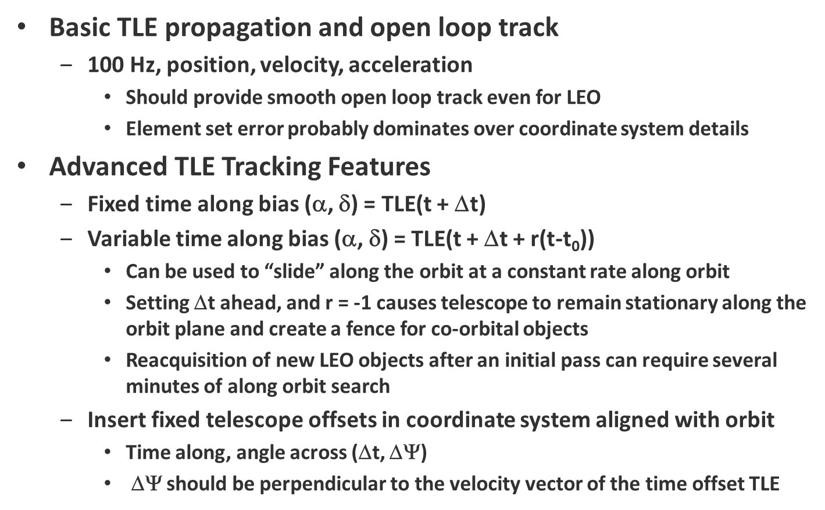

Figure . Basic Satellite Tracking Functional Requirements.

In addition to the basic tracking functions outlined above, effective SSA often requires searching for the target of interest. Generally, these searches are relative to a nominal TLE that has been provided that is inaccurate. The inherent errors in TLEs cause the actually satellite position to be in error typically “along” the orbit. This is a consequence of the orbital plane being well determined, but the orbit mean motion (or equivalently the semi-major axes), eccentricity, or mean anomaly are poorly determined. Effective searches must be oriented and move along with the predicted motion of the object.

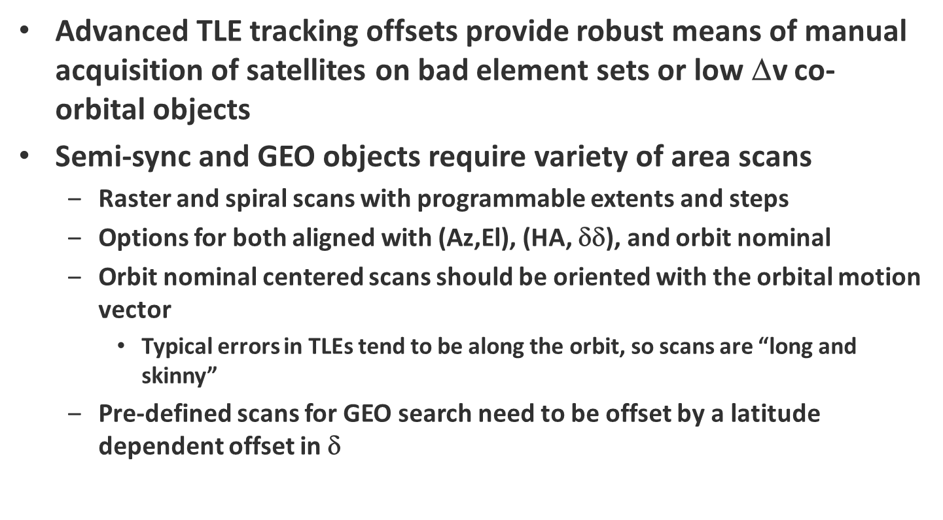

Figure . Advanced Satellite Search Requirements.

### GEO Synoptic Astrometric/Photometric Survey

The Pomenis Astrograph will be operated robotically to perform a continuous astrometric and photometric survey of the deep space satellite population. These observing protocols will be initially automated using ACP. As full integration with ARTN occurs in the future, this functionality could be transitioned the RTS-2, or remain on ACP. Pomenis will have an independent suite of weather sensors.

The capabilities of the Pomenis system are unique at SO in terms of the combination of field-of-view (5 deg) and sensitivity (17-18 *mv* in 30 s). Potentially, Pomenis will be the best suited system to respond to gravity wave transient alerts.

### Individual Satellite Observations

#### Astrometry

Satellite catalog maintenance is based on performing initial orbit determination (IOD) and differential orbit correction (DOC) using positional data provided by radar and optical systems. Optical data provides “angles only” data, which is basically the SSA analog of astrometric data. Although there are important differences in the treatment of reference coordinate systems and aberrational corrections, the techniques are similar to astronomical techniques used for near Earth asteroids.

Typical key performance metrics are listed below for common SSA applications.

* Angular rate: 200-3000 arcsec/s LEO, 0-200 arcsec/s deep space
* Sensitivity: LEO 0-14 *mv*, 8 *mv* typical; deep space 10-20 *mv*, 14 *mv* typical
* Accuracy: < 1 arcsec RMS minimum, 0.2 arcsec RMS nominal
* Timing accuracy: LEO 30 µs, deep space 1 ms.
* Observation tempo: 5-20 observations with spacing from 1-10 s typical per satellite

In deep space, these performance requirements can be met by an on-field astrometric solution using the backgrounds stars as the astrometric reference. Due to the non-sidereal motion of the satellite, either the stars or the satellite will be streaked. As the sensitivity limit of the telescope is challenged, the background star streak length will be too long to provide an adequate reference and more sophisticated techniques must be used.

In LEO achieving astrometric accuracy can be significantly more difficult due to the high rate and non-linear motion of the satellite across the focal plane. In this case, sequences of sidereal frames calibration frames can be taken during the track and used as a reference. Consequently accurate astrometric collection on LEO objects can require a complicated sequence of data and calibration frames.

#### Photometry

Satellite brightness varies for several reasons, including size, orientation, and composition of the exterior surfaces of the satellite. Additionally, object brightness may change on timescales of ms to 100s of seconds due to rotation and changes in phase angle[4]. In US operational space surveillance, photometric collection and calibration is a relatively straight forward process using adaptations of relative photometry techniques, and using a custom “open CCD” band to maximize sensitivity. Typical time resolution is 100 Hz, and photometric accuracy is on the order of 0.1-0.2 *mv*.

In the research environment, photometric data collection requirements are more complex, and the techniques employed cover a wide range. The photometric data collections and requirements below are representative of the research interests and techniques in SSA today.

##### Broadband Photometric Estimate

These measurements estimate the overall brightness of a satellite in either a “open” unfiltered CCD band, or in a broad standard filter such as the Johnson BVRI or Sloan u’ g’ r’ or i’ bands. Integration times average out rotation of the object itself, and the observation provides a magnitude at a phase angle. These measurements can usually be taken serendipitously with astrometric data.

* Photometric accuracy: 5-10%
* Sensitivity: 10-20 *mv*, 14 *mv* typical
* Band: unfiltered, or Johnson BVRI or Sloan u’ g’ r’ or i’ bands

##### Multi-Color Photometry

Multi-color photometry is used to characterize satellite material composition, or to discriminate between different satellites. In general, the red and near-IR end of the spectrum is more diagnostic than the blue end of the spectrum. Since satellites vary for many reasons, including rotation and phase angle, the near-simultaneous or simultaneous collection in the different color bands is critical to the success of these measurements. As a result of these temporal variations in brightness and color, using traditional astronomical CCD photometry can be very problematic for SSA measurements due to the slow CCD readout and filter transition changes.

Minimum requirements to support SSA for stable deep space targets can be summarized as follows:

* Photometric accuracy: 5-10%
* Sensitivity: 10-16 *mv*, 14 *mv* typical
* Band: unfiltered, or Johnson BVRI or Sloan u’ g’ r’, i’, z’ bands
* Data rate: 1-0.1 Hz
* Filter transition rate: 1 s

##### Temporal Photometry

The analysis of satellite light curves has been fundamental to SSA since the first satellites were launched. Nonetheless, most analysis in the field has been limited to stability assessment and rotational period determination. Most satellites once they are no longer controlled will begin to spin at rates that are typically 0.1-10 rpm. In order to support simple stability assessments, the same basic performance requirements as outlined in §3.3.2.2.2 is required.

##### Chimera High Speed Multi-Color Photometer

Because of the deficiencies in the current slow CCD photometric capabilities of the traditional CCD cameras at Steward Observatory, the UA SSA group is developing a high speed multi-color photometry specifically for SSA measurements. The photometer uses three Princeton Instruments EM-CCD cameras and operates in the Sloan r’, i’, and z’ bands. Data rates more than 1000 Hz are possible. The instrument is designed specifically for the Kuiper 61” telescope, but in the future, additional optical assemblies will be able to adapt Chimera to the Bok 90”.

The specific requirements to support Chimera in the ARTN include:

* Integration of the Princeton Lightfield data acquisition system and the Chimera Instrument Control Computer with the OCS layer of ARTN.
* Acquisition and guiding of sidereal and non-sidereal targets.

The technical performance specifications of Chimera our summarized below:

* Photometric accuracy: 2-5%
* Sensitivity: 10-16 *mv*, 14 *mv* typical
* Simultaneous Sloan r’, i’, and z’ bands (can be reconfigured to have a g’ channel).
* Data rate: 1-1000 Hz

#### Search

A frequent SSA need is to search for and locate newly launched, maneuvered, or deployed objects on orbit.

#### SSA Responsive Network Testbed

Test bed for scheduling diverse network of SSA telescopes. In SSA, this is called dynamic scheduling (per observation, equivalent of broker in astronomy), and tasking (daily).

Include allocation of resource appropriate for required measurement and observability constraints

Responsive cueing for anomaly detection (currently part of the SSA daily tasking cycle)

Executing of multi-static observations

#### Scheduling and Execution of SSA Measurements

#### Routine cue observing

Routine collection of astrometric and photometric data required to maintain databases and catalogs for research needs (like a GEO HAMR catalog). Typical frequency 1 d to 3 d, individual collection times of 5-20 min

#### Responsive high priority observing

SSA equivalent of astronomical ToO. Response times and scheduling may require response < 5 min, and scheduling to observations windows of < 5 min

## Educational Requirements

Preserve current student access and interfaces to telescopes used to support education

Provide observing floor, local control room, remote control room, and cue observing experience to students

## Functional, Operational, and Sustainment Requirements

### Facility Startup, Shutdown, and Safety

Lightning protection disconnects

Power distribution, control, and monitoring

Weather instrumentation

Watchdog shutdown

### Safety

Summarize current safety practices and standards

Lockout

Authorization for remote operations

CCTV

### Metrological Instrumentation

Basics (T, P, wind, humidity)

Precipitation

All-sky camera

Lightning

Daylight

Redundancy

### Cybersecurity

### User Interface

### Data Handling

### Commonality

# Development Plan

# References

# Appendix A: Acronym List

AFSPC

ARTN

ASCOM

AzCAM

CCD

COTS

CSS

GCN

GEO

GRB

GW

KPP

LEO

LSST

MMT

NCS

NG-TCS

OCS

PC-TCS

PI

RMS

RTS-2

SDSS

SN

SO

SSA

SuperLOTIS

TAC

TCS

TCS-NG

TLE

ToO

VATT

ZTF

1. The MMT version of Comsoft PC-TCS is a modified non-standard instance that is not maintained by Steward Observatory.
2. Both the Pomenis Astrograph and the Schulman 24” telescope use ACP at the OCS layer.
3. Note that TheSkyX provides features such scripting and high level control features normally implemented at the OCS layer in the ARTN architecture that are not generally used for Pomenis.
4. In the SSA context, phase angle refers to the observer/sun/object angle, and is an exact analog to the angle used in planetary astronomy. In SSA, significant changes in brightness due to phase angle can be observed over minutes and hours.